|  |  |
| --- | --- |
| Project Leader: | Vijaya Vamsikrishna Marrisetty |
| Team Members: | Rakesh Videm, Venkat Kranthi Reddy Madhire, Ajay Kumar Reddy Addula |
| Mentors | Lee, Yugyung, Wahlman, Maude S |

##### **Think you know history?**

Version 1.1

February 21, 2014



History Trivia

Project Plan

# History Trivia

History is the study of the past, specifically how it relates to humans. It is an umbrella term that relates to past events as well as the discovery, collection, organization, and presentation of information about these events.

## Objective

History trivia is mobile game application which is not just a game but also u can challenge the other players in the multiplayer mode and collect different artifacts for each level. There are many quiz applications present in the web, but you can’t access them directly on your mobile web browser. User face compatibility issues while using them on mobile browser. Our objective is to overcome these issue and build a cool user interface application.

## Related Work

History Channel has launched the quiz applications where the users can login or directly play the quiz with single player mode or multiplayer mode. If the user is logged in then the user score will be posted in the cloud and viewed by the other users.

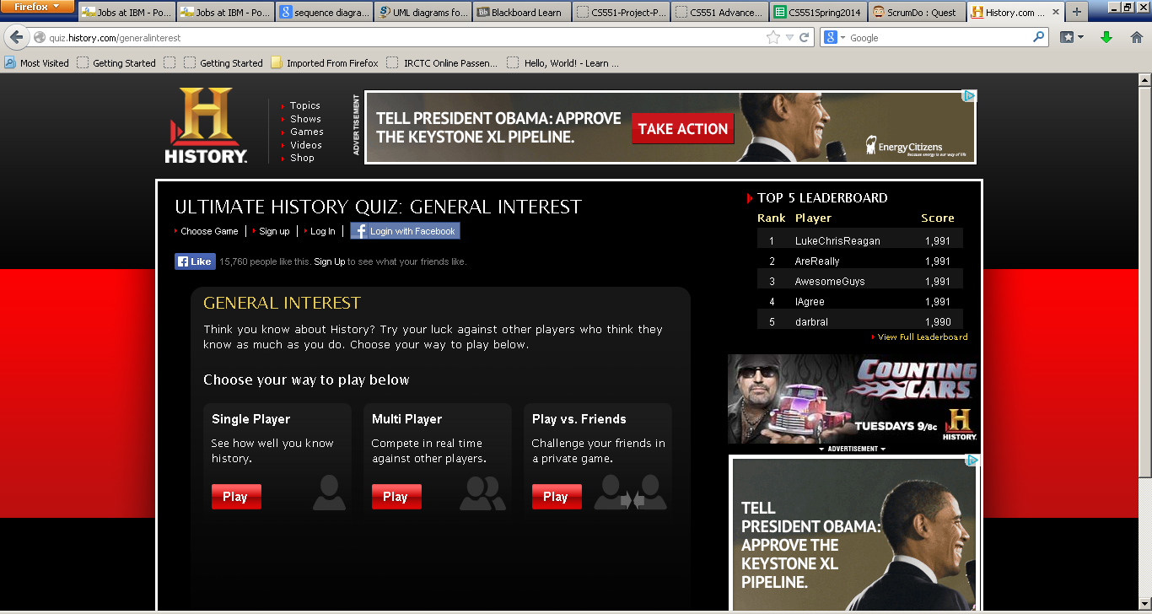

## Requirement Specifications

For development of a game application we have to go through many requirement specifications form technical to non-functional activities. We have described them in the following sections

### Functional Requirements

* Once the student logins to the game app, his name and ID number are displayed on the screen.
* Student has the facility to play a trail version of the game.
* Student can select the on which country he/she wants to play the game.
* For every country he/she plays a score gets updated and shown on the screen.
* Overall score for the game can also be viewed on the screen.
* Once all the countries levels are completed the final score is popped up and an art video which showcases arts of different countries is unlocked.

### non-functional Requirements

* Any number of users can login to the app. No restriction.
* This app is a private app for only the students of a university, hence, the security is maintained through the student login using his/her ID.
* Compatibility is not an issue the users opens the app through google, Firefox, IE, Android, IOS.
* Response time is minimized since our database consists of limited users (here just students of a university).
* Accessibility: Only students from a university can login.

### Technology Requirements

* Student should be able to log in to the app successfully if he has a valid id.
* Able to play the game to test his knowledge or to know more about the history of different countries.
* Student should be able to play a trail game before he actually starts his game.
* Student should be able to view his score on each level and also the total current score.
* Student once completes all the quizzes, an art video should be unlocked.
* Quiz master/admin should be able to post/change the quiz questions.
* Quiz master/admin should be able to view scores of all individual students.
* Quiz master should have separate login to the app.
* Quiz master can block any user from playing the quiz.

## Framework Specificaton

[Define your opportunity qualification process and criteria.]

### Assumptions and Principles

* Considering central data base (Cloud) is out of scope for this project, we assume that the local database as the central database.
* Constrained the application of university students.
* Building a database for whole every student in a university is complex, hence we limit student of the university to 10-15.

### System architecture diagram



## System Specification

### Existing Service

In the existing service the user is just answering the questions and gathering the score. Which won’t make the users to involve more into the game.

### New service to build

In the serve in which we make the user to interact with the other users. User will be able to collect rare artifact pictures as a reward.

* Class Diagram

The below structure describes the number of classes present and the interaction between them.



* Sequence Diagram



## Design of Mobile Client

The design of the application goes with REST process, where the user can access the application from any device he like. We are trying to implement the application on all leading platforms like IOS, Android and windows phone.

## Future Scope

In future we want to take the game to more into the graphical and interactive way. The final appearance we are trying to make is more similar to SIMS.

## Technical and architectural requirements

User Interface (Web Framework)**:**

* HTML
* CSS
* JavaScript

Back End:

* UMKC Student Database
* SQL server 2014

Web Services:

* Microsoft Visual Studio 2010 ( C#)
* UMKC Server

UML /Architecture Diagrams**:**

* Microsoft Visio 2013
* Visual Paradigm

## Project Timelines

| Task | Start Date | End Date |
| --- | --- | --- |
| Gathering requirements | 2/4/13 | 2/11/13 |
| Planning | 2/12/13 | 2/21/13 |
| Implementation | 2/25/13 | 4/2/13 |
| Testing | 4/3/13 | 4/25/13 |
| Documentation | 4/26/13 | 5/1/13 |
| Deployment | 5/1/13 | ----------- |

# Team Sign-off

|  |  |  |
| --- | --- | --- |
| Vijaya Vamsikrishna Marrisetty | MVVK | 02/21/2014 |
| Print First and Last Name | Signature | Date |
| Rakesh Videm | RV | 02/21/2014 |
| Print First and Last Name | Signature | Date |
| Venkat Kranthi Reddy Madhire | KR | 02/21/2014 |
| Print First and Last Name | Signature | Date |
| Ajay Kumar Reddy Addula | AKR | 02/21/2014 |
| Print First and Last Name | Signature | Date |